**BLOOD BANK**

Use case diagram:

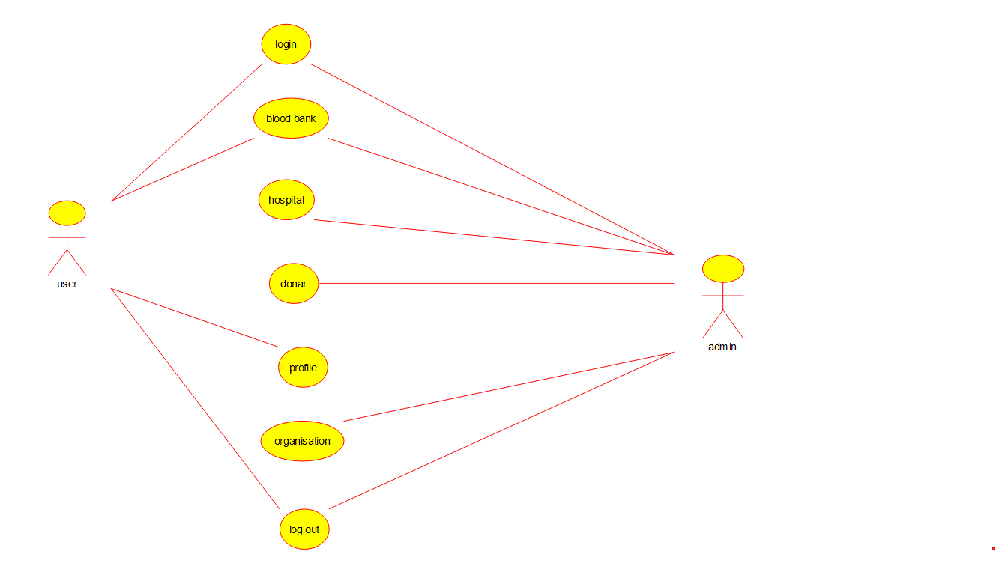

Activity diagram:

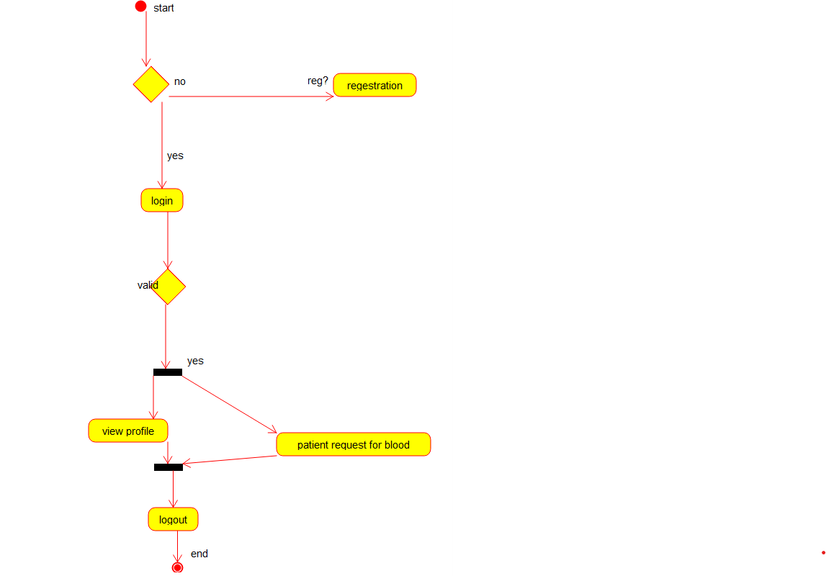

Object diagram:

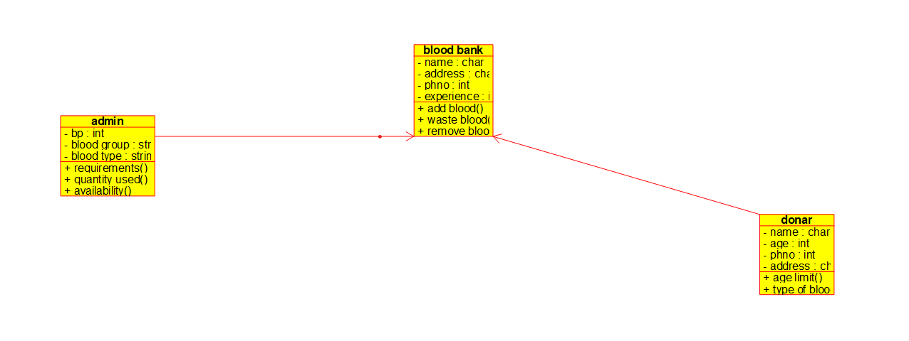

Sequence diagram:

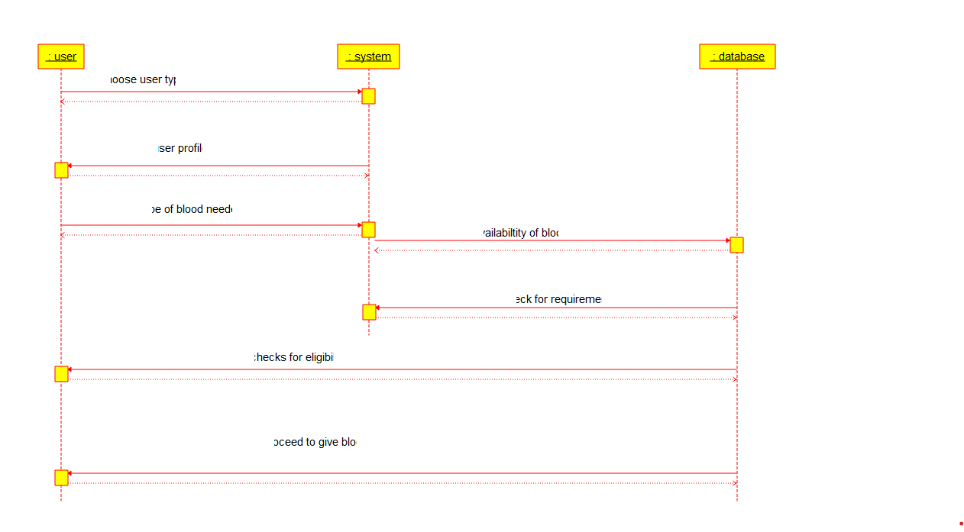

Collaboration diagram:

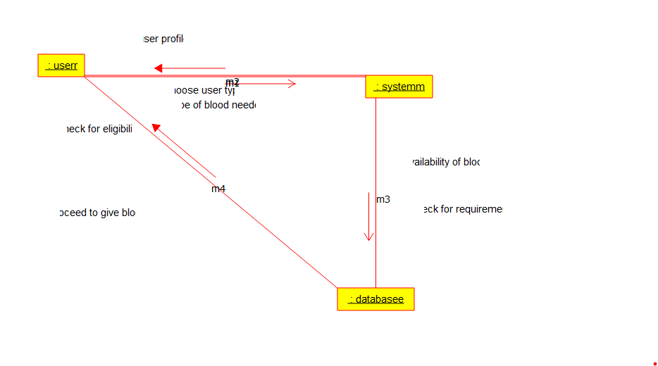

Deployment diagram: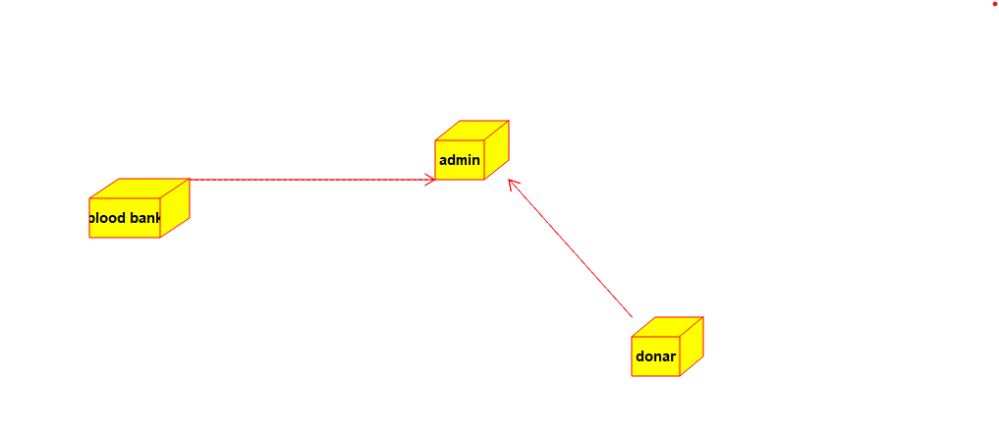

Component diagram:

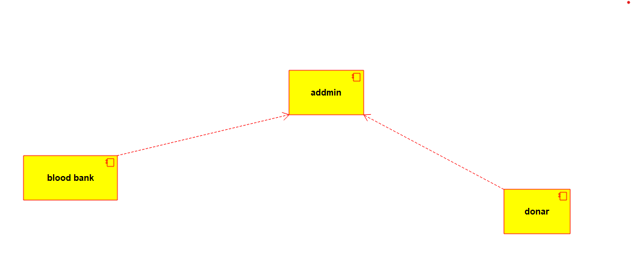

Program:

Donar:

/**

* Class admin

*/

public class admin {

//

// Fields

//

private int bp;

private String blood_group;

private String blood_type;

//

// Constructors

//

public admin () { };

//

// Methods

//

//

// Accessor methods

//

/**

* Set the value of bp

* @param newVar the new value of bp

*/

private void setBp (int newVar) {

bp = newVar;

}

/**

* Get the value of bp

* @return the value of bp

*/

private int getBp () {

return bp;

}

/**

* Set the value of blood_group

* @param newVar the new value of blood_group

*/

private void setBlood_group (String newVar) {

blood_group = newVar;

}

/**

* Get the value of blood_group

* @return the value of blood_group

*/

private String getBlood_group () {

return blood_group;

}

/**

* Set the value of blood_type

* @param newVar the new value of blood_type

*/

private void setBlood_type (String newVar) {

blood_type = newVar;

}

/**

* Get the value of blood_type

* @return the value of blood_type

*/

private String getBlood_type () {

return blood_type;

}

//

// Other methods

//

/**

*/

public void requirements()

{

}

/**

*/

public void quantity_used()

{

}

/**

*/

public void availability()

{

}

}

/**

* Class donar

*/

public class donar {

//

// Fields

//

private char name;

private int age;

private int phno;

private char address;

//

// Constructors

//

public donar () { };

//

// Methods

//

//

// Accessor methods

//

/**

* Set the value of name

* @param newVar the new value of name

*/

private void setName (char newVar) {

name = newVar;

}

/**

* Get the value of name

* @return the value of name

*/

private char getName () {

return name;

}

/**

* Set the value of age

* @param newVar the new value of age

*/

private void setAge (int newVar) {

age = newVar;

}

/**

* Get the value of age

* @return the value of age

*/

private int getAge () {

return age;

}

/**

* Set the value of phno

* @param newVar the new value of phno

*/

private void setPhno (int newVar) {

phno = newVar;

}

/**

* Get the value of phno

* @return the value of phno

*/

private int getPhno () {

return phno;

}

/**

* Set the value of address

* @param newVar the new value of address

*/

private void setAddress (char newVar) {

address = newVar;

}

/**

* Get the value of address

* @return the value of address

*/

private char getAddress () {

return address;

}

//

// Other methods

//

/**

*/

public void age_limit()

{

}

/**

*/

public void type_of_blood()

{

}

}

Blood bank:

/**

* Class admin

*/

public class admin {

//

// Fields

//

private int bp;

private String blood_group;

private String blood_type;

//

// Constructors

//

public admin () { };

//

// Methods

//

//

// Accessor methods

//

/**

* Set the value of bp

* @param newVar the new value of bp

*/

private void setBp (int newVar) {

bp = newVar;

}

/**

* Get the value of bp

* @return the value of bp

*/

private int getBp () {

return bp;

}

/**

* Set the value of blood_group

* @param newVar the new value of blood_group

*/

private void setBlood_group (String newVar) {

blood_group = newVar;

}

/**

* Get the value of blood_group

* @return the value of blood_group

*/

private String getBlood_group () {

return blood_group;

}

/**

* Set the value of blood_type

* @param newVar the new value of blood_type

*/

private void setBlood_type (String newVar) {

blood_type = newVar;

}

/**

* Get the value of blood_type

* @return the value of blood_type

*/

private String getBlood_type () {

return blood_type;

}

//

// Other methods

//

/**

*/

public void requirements()

{

}

/**

*/

public void quantity_used()

{

}

/**

*/

public void availability()

{

}

}

/**

* Class blood_bank

*/

public class blood_bank {

//

// Fields

//

private char name;

private char address;

private int phno;

private int experience;

//

// Constructors

//

public blood_bank () { };

//

// Methods

//

//

// Accessor methods

//

/**

* Set the value of name

* @param newVar the new value of name

*/

private void setName (char newVar) {

name = newVar;

}

/**

* Get the value of name

* @return the value of name

*/

private char getName () {

return name;

}

/**

* Set the value of address

* @param newVar the new value of address

*/

private void setAddress (char newVar) {

address = newVar;

}

/**

* Get the value of address

* @return the value of address

*/

private char getAddress () {

return address;

}

/**

* Set the value of phno

* @param newVar the new value of phno

*/

private void setPhno (int newVar) {

phno = newVar;

}

/**

* Get the value of phno

* @return the value of phno

*/

private int getPhno () {

return phno;

}

/**

* Set the value of experience

* @param newVar the new value of experience

*/

private void setExperience (int newVar) {

experience = newVar;

}

/**

* Get the value of experience

* @return the value of experience

*/

private int getExperience () {

return experience;

}

//

// Other methods

//

/**

*/

public void add_blood()

{

}

/**

*/

public void waste_blood()

{

}

/**

*/

public void remove_blood()

{

}

}